The Story of the Milking Cow and Goat Project in Meru, Kenya
A Story of Hope, Partnership and Transformation

How the Project Began
In 2007, Australian Rotarian Wilma Best attended a Rotary District Conference in Kampala, Uganda, where she spoke about a simple idea – providing milk to hungry children through donated dairy animals. Among the audience was Reverend Father Jason Micheni of the Rotary Club of Meru, Kenya. After the conference he sought Wilma out and explained the desperate need facing children and families in Meru County. For three years they planned together before Wilma travelled to Kenya and confirmed the extent of poverty. In 2010 the first Holstein Friesian dairy cows were delivered to a primary school, providing fresh milk for more than 300 children.

Growing the Vision
The project soon expanded from dairy cows to goats. Goats were ideal for poorer families because they require less land, reproduce quickly and provide nutritious milk. Grandmothers caring for orphaned children were among the first recipients. Rotary clubs in Australia raised funds while the Rotary Club of Meru coordinated local implementation, training and follow-up.
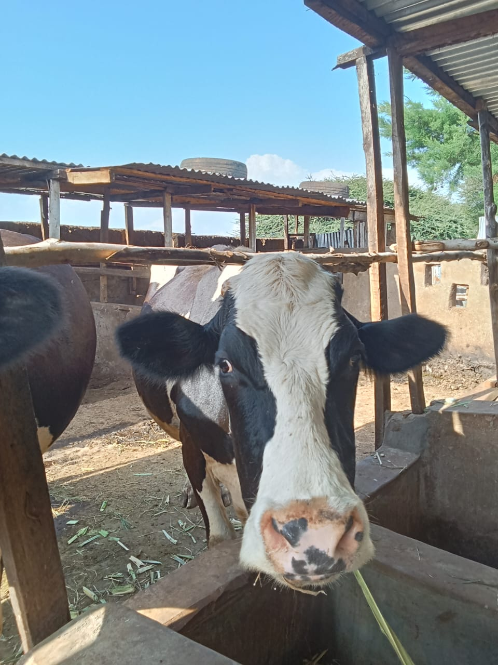

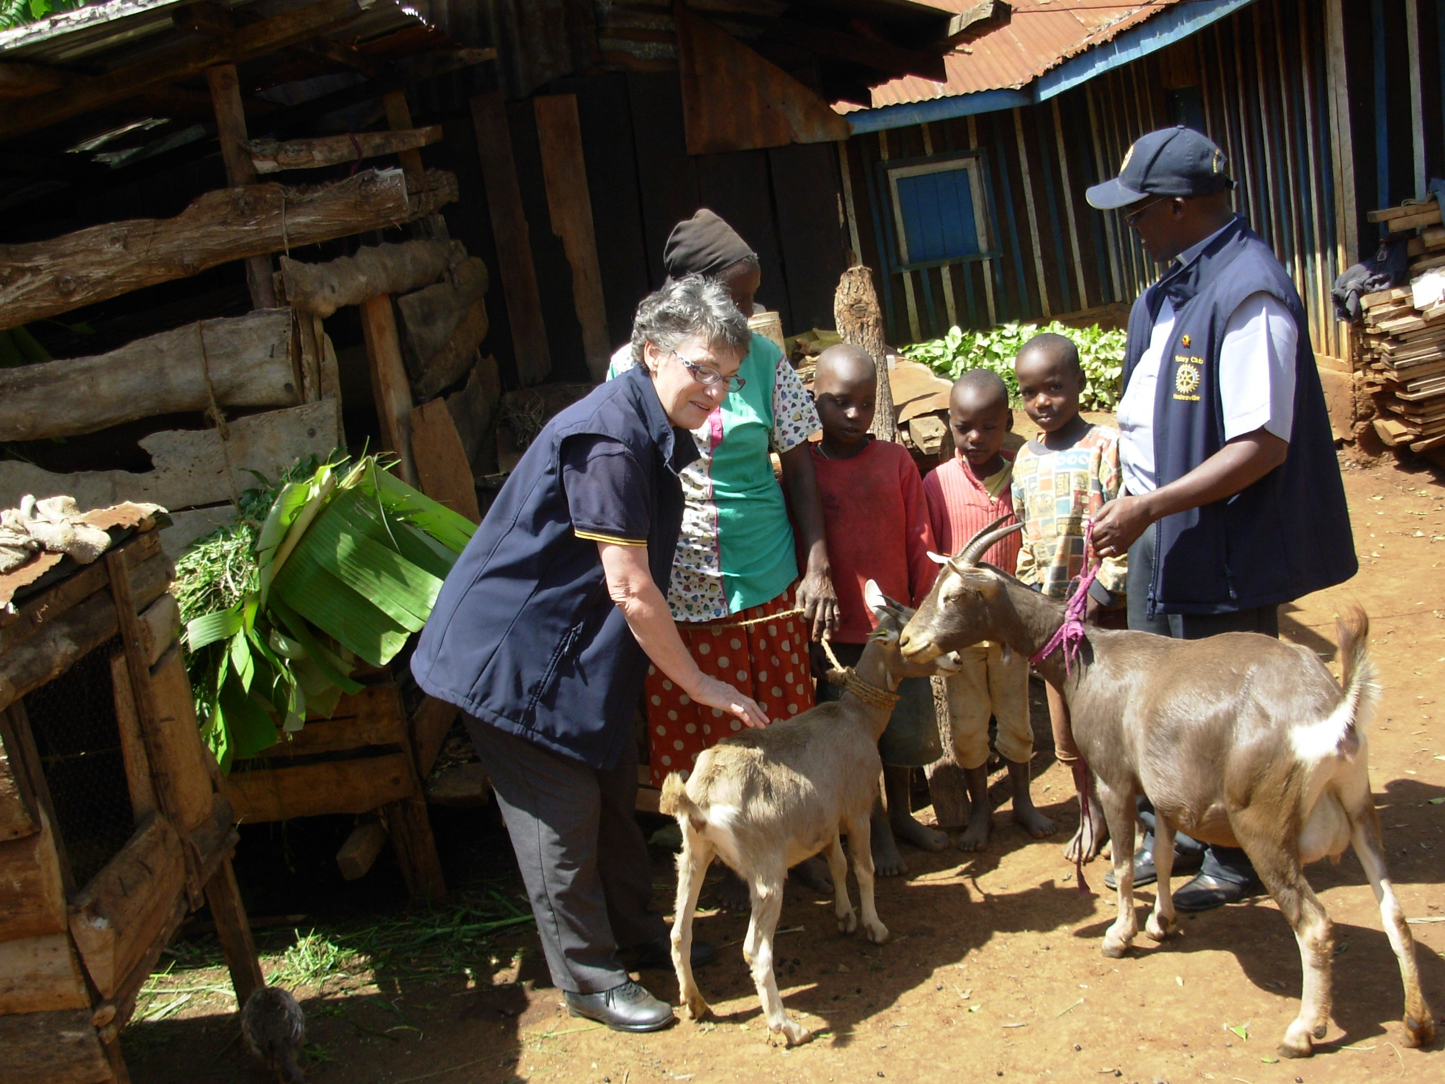

Results So Far
Over the years the project has:
• Supplied dairy cows to schools and community sites.
• Distributed dozens of dairy goats to vulnerable families.
• Improved nutrition for hundreds of children.
• Created income from the sale of surplus milk and the offspring of goats.
• Helped families pay school fees and medical expenses.
• Built stronger partnerships between the Rotary Clubs of Healesville, Bayswater, Meru and many supporters.
- The income creates self sufficiency and provides sustainability
The success of the livestock project has also inspired further community development initiatives, including the current Kithima Borehole Project, which aims to provide reliable water for people, livestock and food production.

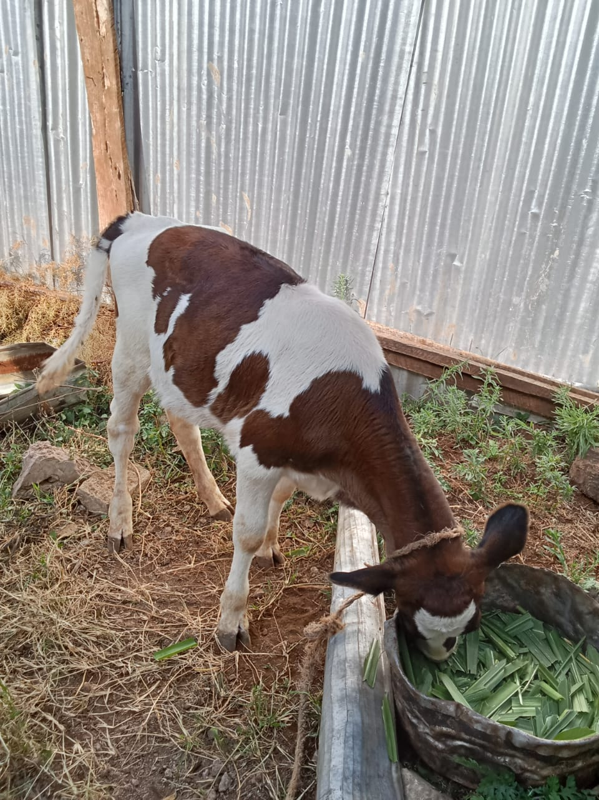

A Lasting Legacy
What began as one conversation at a Rotary conference has become a long-term partnership that has changed many lives. Every cow and every goat represents more than an animal—it represents nutrition, dignity, education, opportunity and hope for families in Meru.

Suggested Photographs
Insert high-quality photographs of:
• Dairy cows in rural Kenya
• Dairy goats with village families
• Children drinking fresh milk at school
• Rotary members handing over livestock
These should be replaced with photographs for which you have permission to publish.

